EXPT NO: 6 | IMPLEMENTATION OF LONG SHORT-TERM MEMORY (LSTM) FOR SENTIMENT ANALYSIS
DATE: 12/10/2026

PRE-LAB QUESTIONS (PROVIDE BRIEF ANSWERS TO THE FOLLOWING QUESTIONS)

Name: Midhun P Roll No: 24BAD069

Git Hub Link:

- Explain the working of Long Short-Term Memory (LSTM) networks in processing sequential data.

LSTM is a type of Recurrent Neural Network (RNN) used to process sequential data. It maintains information using a cell state and hidden state. It uses input, forget and output gates to control information flow. These gates help retain important information over long sequences. LSTM is useful for learning patterns in text and other sequential data.

- Discuss why is LSTM considered suitable for sentiment analysis of textual data?

LSTM can learn the order and context of words in a sentence. It remembers important information from previous words while processing a review. This helps it understand positive and negative expressions. It can also learn long-term dependencies between words. Therefore, LSTM is suitable for classifying movie reviews based on sentiment.

- Explain the role of memory cells and gates in an LSTM network.

Memory cells store important information from previous time steps. The forget gate removes unnecessary information from the cell state. The input gate controls the storage of new information. The output gate determines which information is passed to the next step. Together, they help LSTM learn meaningful patterns from sequential data.

- Explain the importance of tokenization during text preprocessing for sentiment analysis.

Tokenization divides text into smaller units called tokens, usually words. For example, “The movie is good” becomes four tokens. Each token can be assigned a unique numerical index. This makes text easier for the model to process. Tokenization is an important step in sentiment analysis.

- Why should textual data be converted into numerical representations before training an LSTM model?

Neural networks cannot directly process raw textual data. Therefore, words are converted into numerical indices. These indices are further converted into vectors using an embedding layer. Numerical representations allow the LSTM to learn patterns in text. This helps the model classify sentiments effectively.

AIM
To implement a Long Short-Term Memory (LSTM) neural network for sentiment analysis and classify textual data into appropriate sentiment categories based on the learned linguistic patterns.

SOFTWARE REQUIREMENTS
- Python
- TensorFlow / Keras / PyTorch
- Google Colab
- GitHub
- NumPy
- Matplotlib
- Pandas

OBJECTIVES
Students will be able to:
- Understand the architecture and working of Long Short-Term Memory (LSTM) networks.
- Understand the role of LSTM in processing sequential textual data.
- Perform text preprocessing techniques for sentiment classification.
- Convert textual data into numerical sequences suitable for LSTM models.
- Build and train an LSTM-based sentiment classification model.
- Evaluate the performance of the trained LSTM using appropriate classification metrics.
- Analyze the effectiveness of LSTM in learning contextual and sequential patterns from textual data.

PROCEDURE
PART A: DATASET PREPARATION
Perform the following tasks:
- Load a suitable sentiment analysis dataset such as the IMDB Movie Reviews dataset.
- Explore the dataset and examine sample reviews and their corresponding sentiment labels.
- Identify the positive and negative sentiment classes.
- Perform basic text preprocessing such as converting text to lowercase, if required.
- Remove unnecessary characters or symbols, if required.
- Tokenize the reviews into words.
- Build a vocabulary and assign unique integer indices to words.
- Convert the text reviews into numerical sequences.
- Apply sequence padding to obtain inputs of equal length.
- Split the prepared dataset into training and validation/testing datasets.

(CODE: CONATAINS STUDENT ROLL NOS
SCREENSHOT OF CODE
SCREENSHOT OF OUTPUT)
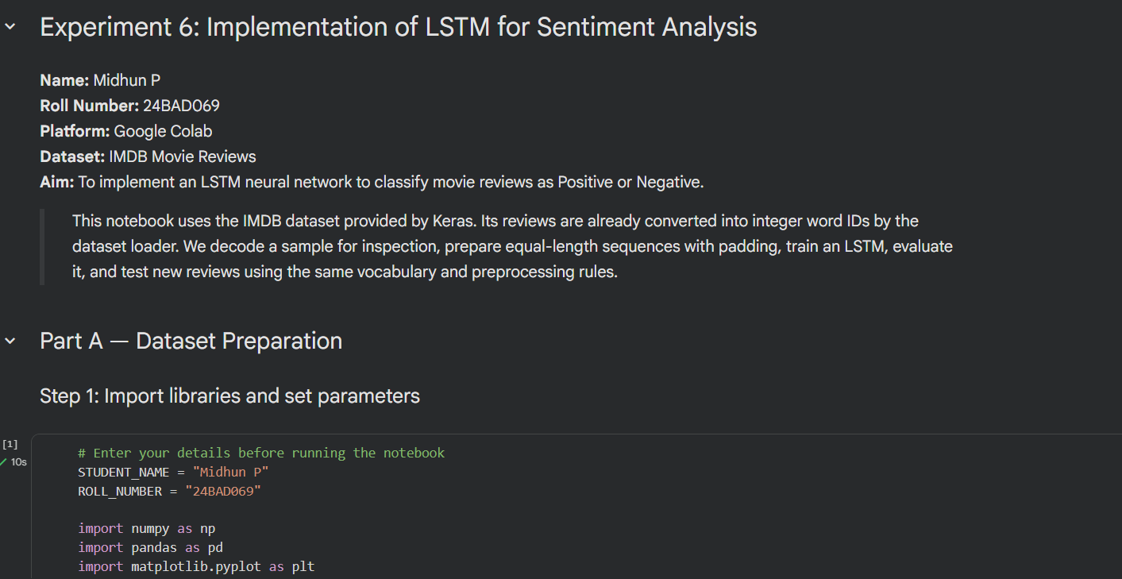
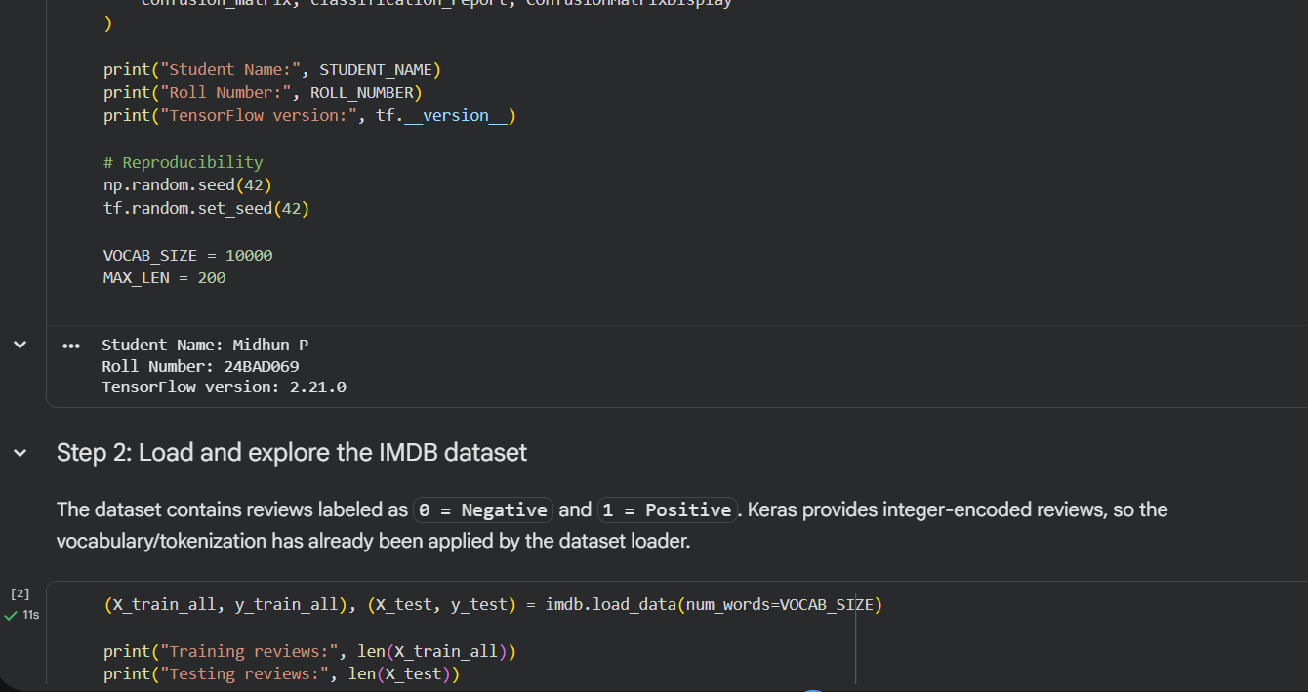

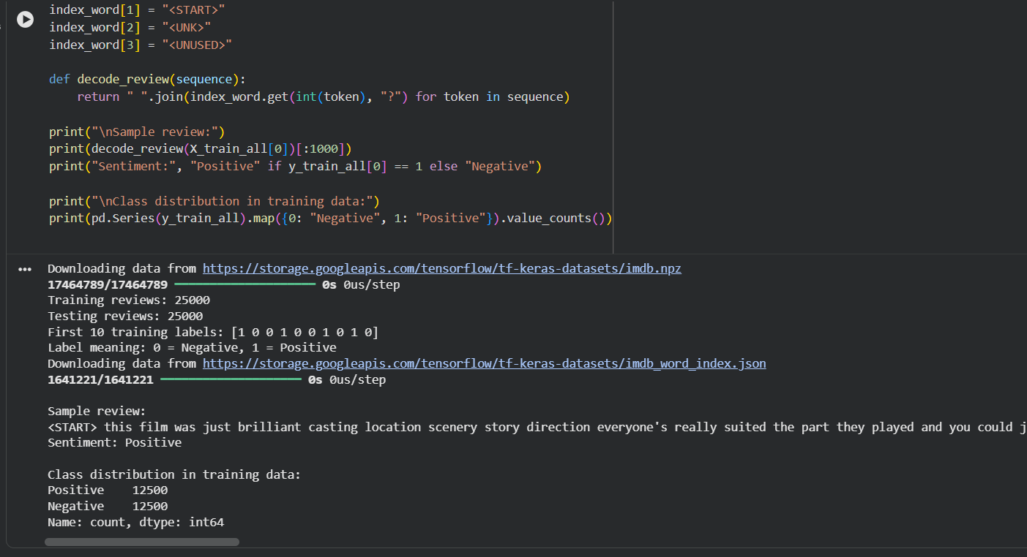

PART B: IMPLEMENTING THE LSTM MODEL
Perform the following tasks:
- Create an Embedding layer to convert words into dense vector representations.
- Add an LSTM layer to learn long-term sequential dependencies in the reviews.
- Add a Dense output layer for sentiment classification.
- Use an appropriate activation function such as Sigmoid for binary sentiment classification.
- Compile the model using an appropriate optimizer and loss function.
- Display the model architecture and model summary.

(CODE: CONATAINS STUDENT ROLL NOS
SCREENSHOT OF CODE
SCREENSHOT OF OUTPUT)
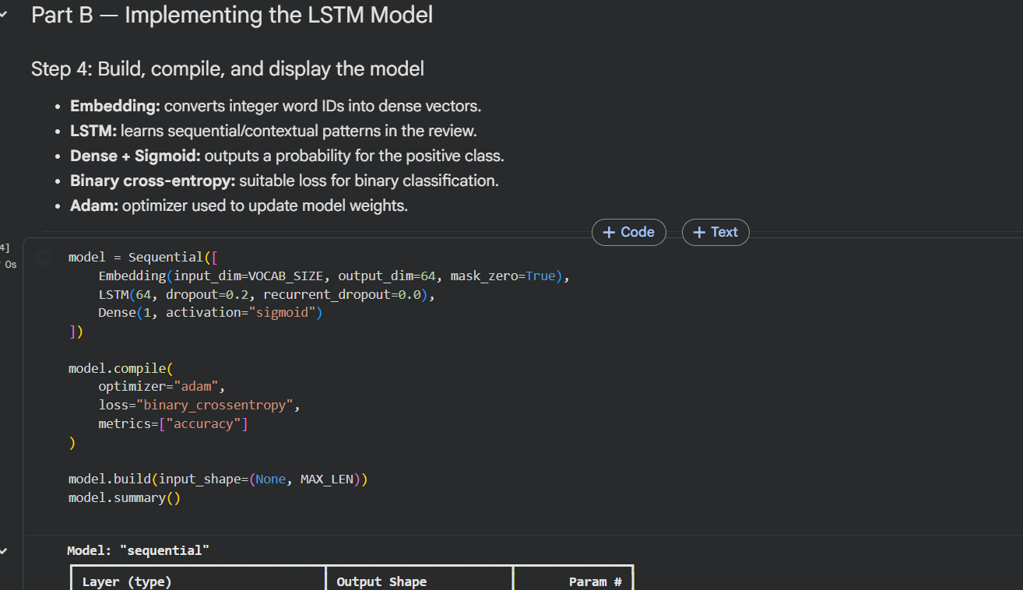
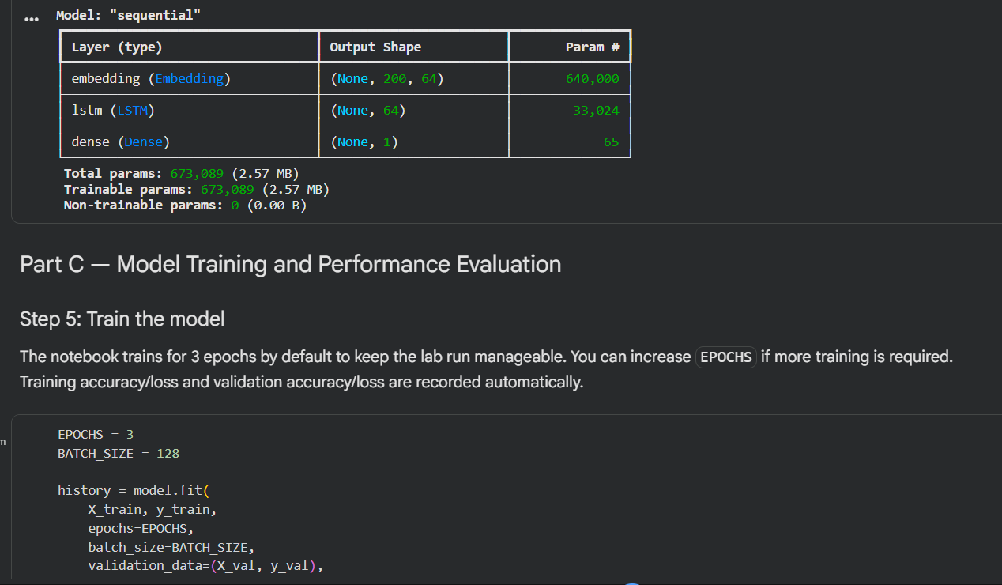

PART C: MODEL TRAINING AND PERFORMANCE EVALUATION
Perform the following tasks:
- Train the LSTM model using the prepared training dataset.
- Validate the model using the validation dataset.
- Record:
  - Training accuracy
  - Validation accuracy
  - Training loss
  - Validation loss
- Evaluate the trained model on the test dataset.
- Calculate suitable evaluation metrics such as:
  - Accuracy
  - Precision
  - Recall
  - F1-score
- Generate a confusion matrix to analyze the classification performance.
- Visualize:
  - Accuracy vs. Epoch
  - Loss vs. Epoch

(CODE: CONATAINS STUDENT ROLL NOS
SCREENSHOT OF CODE
SCREENSHOT OF OUTPUT)
vv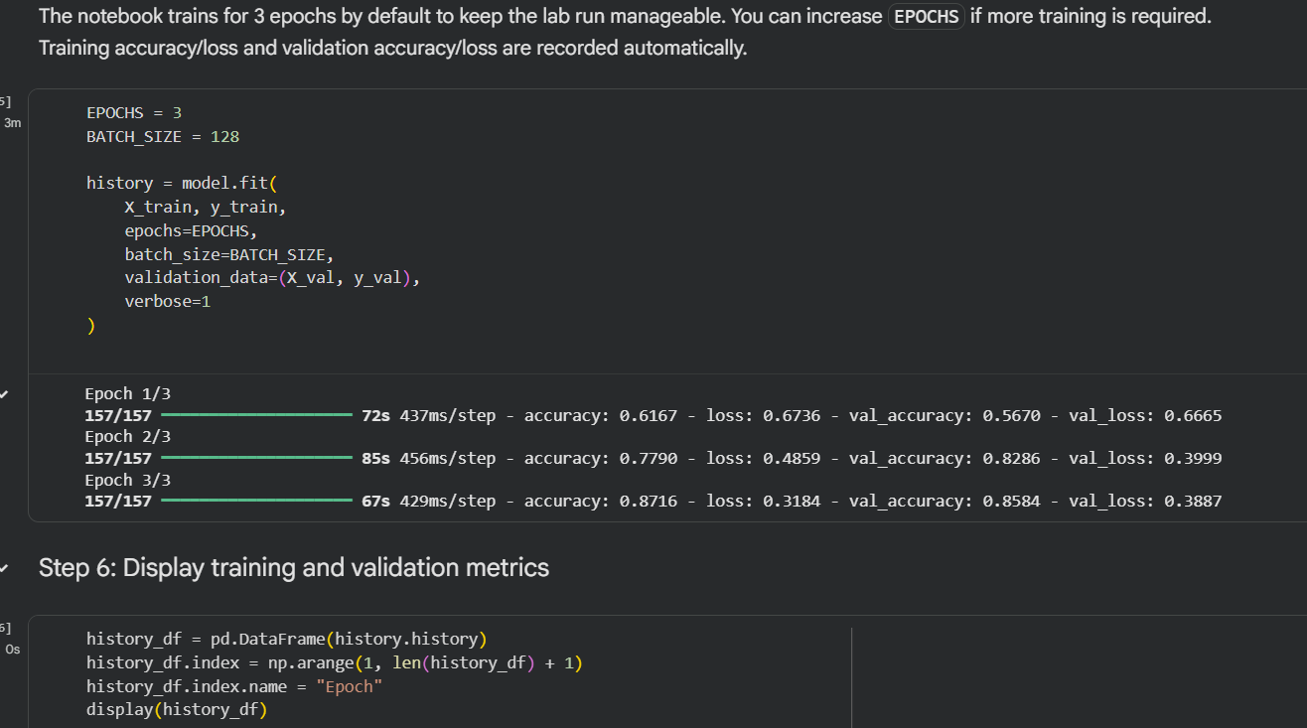
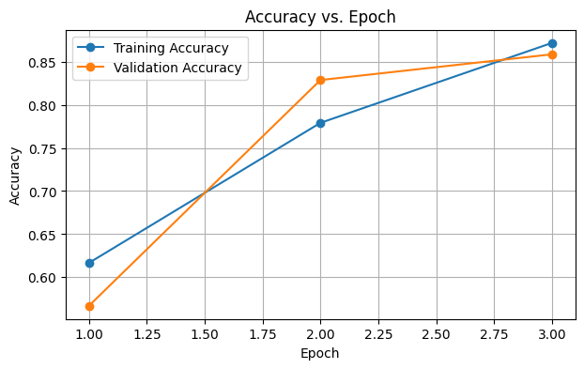
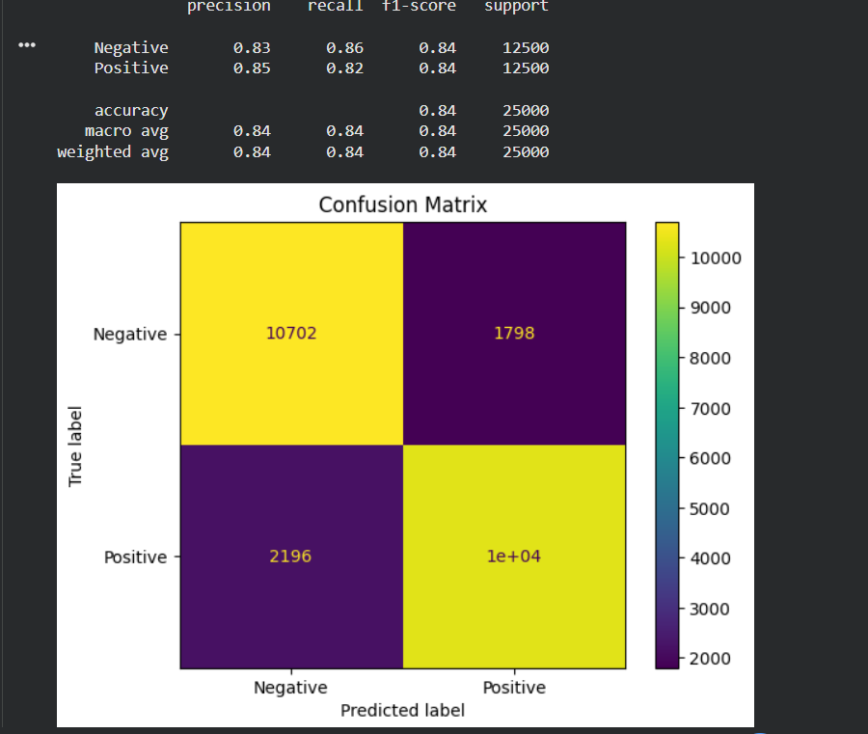

PART D: SENTIMENT PREDICTION AND DEEP LEARNING EXPERIMENT MANAGEMENT

Perform the following tasks:
- Provide new movie-review sentences as input to the trained LSTM model.
- Preprocess and tokenize the input text using the same vocabulary used during training.
- Apply sequence padding to the input text.
- Predict the sentiment using the trained LSTM model.
- Classify the input as Positive or Negative based on the predicted probability.
- Provide multiple review samples with different sentiments.
- Compare the predicted sentiment with the actual/expected sentiment.
- Analyze the coherence and correctness of the model predictions.
- Document the observations and upload the notebook to GitHub.

(CODE: CONATAINS STUDENT ROLL NOS
SCREENSHOT OF CODE
SCREENSHOT OF OUTPUT)
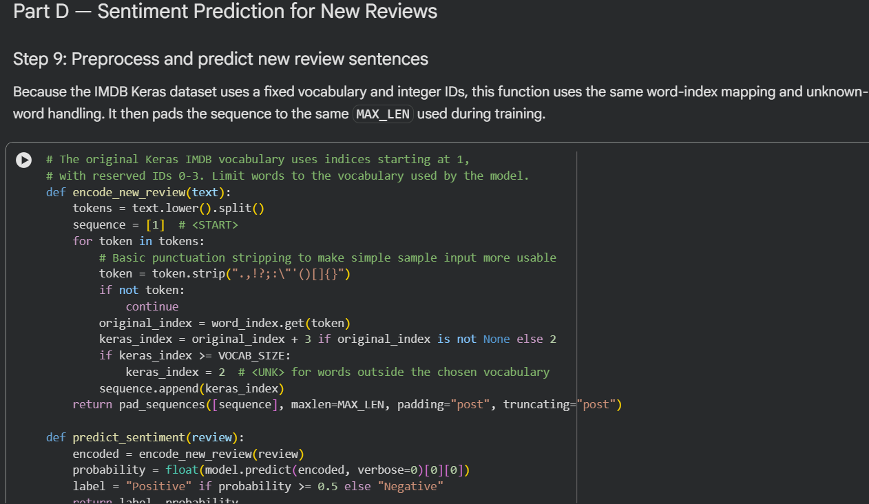
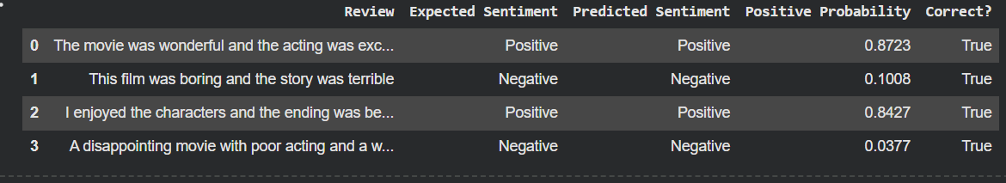

POST-LAB QUESTIONS (PROVIDE BRIEF ANSWERS TO THE FOLLOWING QUESTIONS)

- Explain how the cell state helps an LSTM retain information over long sequences.

The cell state acts as the memory of an LSTM network. It carries important information across multiple time steps. The gates control which information is retained or removed. This helps the model remember relevant details from earlier words. It also reduces the vanishing-gradient problem.

- Describe the functions of the input gate, forget gate, and output gate in an LSTM.

The input gate controls which new information is stored. The forget gate decides which existing information should be discarded. The output gate determines which information is used to produce the hidden state. These gates regulate information flow through the network. They help LSTM learn important sequential patterns.

- Discuss the effect of insufficient training epochs on the performance of an LSTM sentiment classification model.

An epoch represents one complete pass through the training dataset. Insufficient epochs may prevent the model from learning important patterns. This can lead to underfitting and low accuracy. Training and validation loss may remain high. Therefore, a suitable number of epochs is necessary for good performance.

- Explain one advantage of LSTM over a Simple RNN for sentiment analysis.

LSTM can retain important information over longer sequences more effectively than a Simple RNN. It uses a cell state and gates to control information flow. This helps reduce the vanishing-gradient problem. It can learn long-term relationships between words. Therefore, it is useful for analyzing longer movie reviews.

- Discuss how sequence length can affect the accuracy and computational requirements of an LSTM-based sentiment analysis model.

Short sequences require less memory and training time but may lose important information. Long sequences preserve more context but require greater computational resources. Excessively long sequences may also include unnecessary information. Padding makes sequences equal in length, while truncation limits their maximum length. Choosing a suitable sequence length helps balance accuracy and efficiency.

ASSESSMENT
Description | Max Marks | Marks Awarded
Pre Lab Exercise | 5
In Lab Exercise | 10
Post Lab Exercise | 5
Viva | 10
Total | 30
Faculty Signature

